**To Mark Attendance Using Face Recognition**

Submitted in partial fulfillment of the requirements for the award of degree of

**BACHELOR OF ENGINEERING**

**IN**

**COMPUTER SCIENCE & ENGINEERING**



**Submitted to:**

**Dr. Rajendra Kumar**

**Submitted By:**

,Bibek Rawat ,Shreyansh Raut, Subham Sah ,Md. Tauhid Alam,

18BCS6728,18BCS1703, 18BCS6537, 18BCS6588,

**DEPARTMENT OF COMPUTER SCIENCE & ENGINEERING**

**Chandigarh University, Gharuan**

**Project Design:**

Our Project mainly consists of three parts,

1. **Student-id Verification**

In this part, we will take the student identification number as input from the student to confirm whether the student is registered or not and then we will pull out all the needed data from the student database including the student’s picture which we have collected during registration for the detection and verification purposes which comes in the next step.

1. **Face Recognition**

As soon as we get the image from the previous step we will use that to find and store the facial encoding of the student and further this module is further sub divided into two modules.

1. **Detecting Faces**

Before we enter this stage the web camera is and must be already active, by using that we will detect all the faces that are in the frame and capture their encoding arrays and will store them for further use.

1. **Comparing Faces**

As we have all the required data, we can now verify whether the student who provided is really him/ herself or not by comparing the encoded arrays which we stored before and will also find the distance between both faces for a more accurate recognition.

We will pass to the next step only, if all the above executes properly.

1. **Updating Attendance**

If the implementation phase has come this far, then the student must have met all the criteria and thereby we will update the student’s attendance in a CSV file or normal file including the time constraints.

**Innovation in model:**

In this project the main innovation is user friendly and rather than that we are developing web based model so,availability and efficient also a part of innovation.

Following points are the main innovations in our project:

1. simple code or easy to understand code.
2. User friendly
3. cost effective
4. accessibility(access anywhere from the world)

**DFD (Data Flow Diagram):**

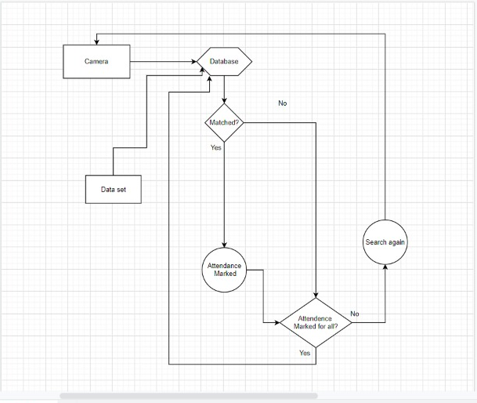

**Flowchart:**

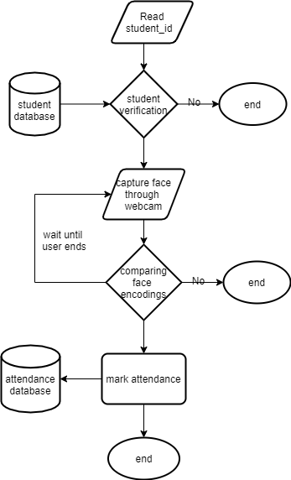

**Implementation:**

We have completed the setting up of the environment and collected all the necessary data so far. We have completed the first module of the project and half way into the second module and in mean time we are doing the third module too. We have implemented almost 50% of the project and importantly the part of encoding the faces too. We have provided the things on what we are working in phase evaluation report.

This our real time code and output.

